# Preparation

Change the settings as follows:

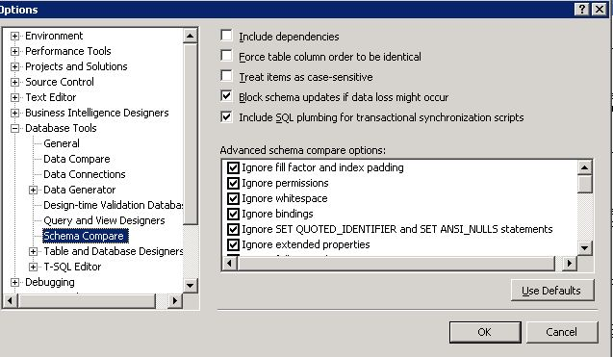

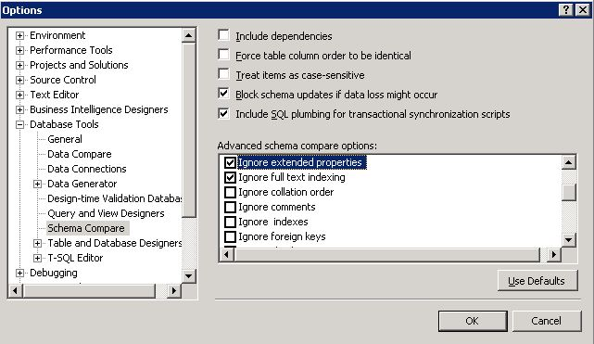

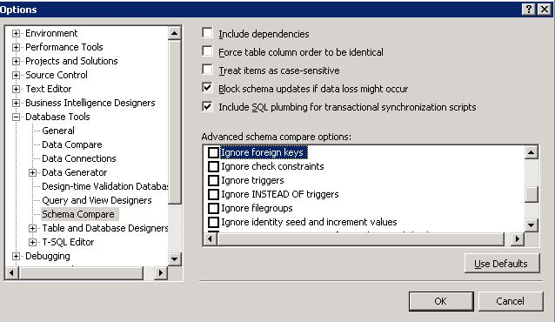

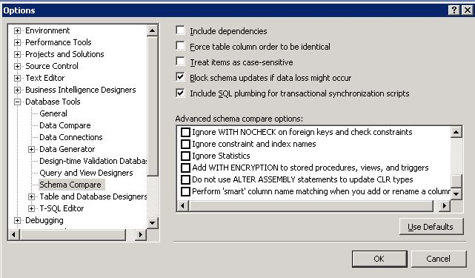

# Compare database schema

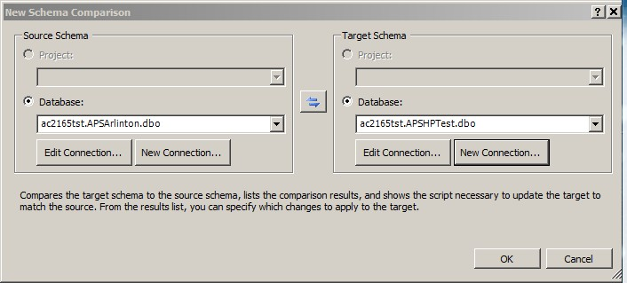

# After comparing finish, only select the ‘tables’ option and export script

In the script, at first, it will drop CONSTRAINT on a table. Secondly, it will create a temp table using the table schema on the source database, and import all the data to it from original table. Then, it will drop the original table and rename the temp table to the original table’s name. At last, the CONSTRAINT will be added back to the table.

**An example as follows:**

* *Drop CONSTRAINT*

ALTER TABLE [dbo].[MODEL_ASSEMBLY_MODEL_JOIN] DROP

CONSTRAINT [MODL_ASMBLY_CD_JN_RI_1],

CONSTRAINT [MODL_ASMBLY_CD_JN_RI_2]

* *Create Temp Table*

CREATE TABLE [dbo].[tmp_ms_xx_MODEL_ASSEMBLY_MODEL_JOIN]

(

[CODE_MODEL_ASSEMBLY_CODE] [nvarchar] (3) COLLATE

SQL_Latin1_General_CP1_CI_AS NOT NULL,

[MODEL_LITERAL] [nvarchar] (7) COLLATE SQL_Latin1_General_CP1_CI_AS NOT NULL,

[MODEL_YEAR_MODEL_LITERAL] [nvarchar] (4) COLLATE SQL_Latin1_General_CP1_CI_AS NOT NULL

) ON [PRIMARY]

* *Import Data and Rename Table*

INSERT INTO [dbo].[tmp_ms_xx_MODEL_ASSEMBLY_MODEL_JOIN]

([CODE_MODEL_ASSEMBLY_CODE], [MODEL_LITERAL], [MODEL_YEAR_MODEL_LITERAL])

SELECT [CODE_MODEL_ASSEMBLY_CODE], [MODEL_LITERAL],

[MODEL_YEAR_MODEL_LITERAL] FROM [dbo].[MODEL_ASSEMBLY_MODEL_JOIN]

DROP TABLE [dbo].[MODEL_ASSEMBLY_MODEL_JOIN]

EXEC sp_rename N'[dbo].[tmp_ms_xx_MODEL_ASSEMBLY_MODEL_JOIN]', N'MODEL_ASSEMBLY_MODEL_JOIN'

* *Add CONSTRAINT*

ALTER TABLE [dbo].[MODEL_ASSEMBLY_MODEL_JOIN] ADD

CONSTRAINT [MODL_ASMBLY_CD_JN_RI_1] FOREIGN KEY

([CODE_MODEL_ASSEMBLY_CODE]) REFERENCES [dbo].[MODEL_ASSEMBLY_CODE]

([CODE_MODEL_ASSEMBLY_CODE]) ON DELETE CASCADE ON UPDATE CASCADE,

CONSTRAINT [MODL_ASMBLY_CD_JN_RI_2] FOREIGN KEY ([MODEL_LITERAL],

[MODEL_YEAR_MODEL_LITERAL]) REFERENCES [dbo].[MODEL_LITERAL]

([MODEL_LITERAL], [MODEL_YEAR_MODEL_LITERAL]) ON DELETE CASCADE

# Execute the script in target database

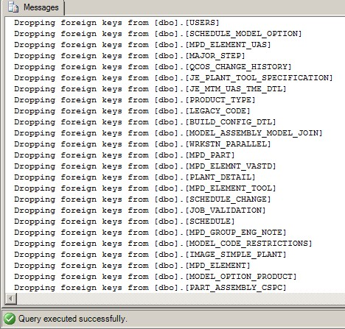

All the script executes successful.

# Compare the schema again

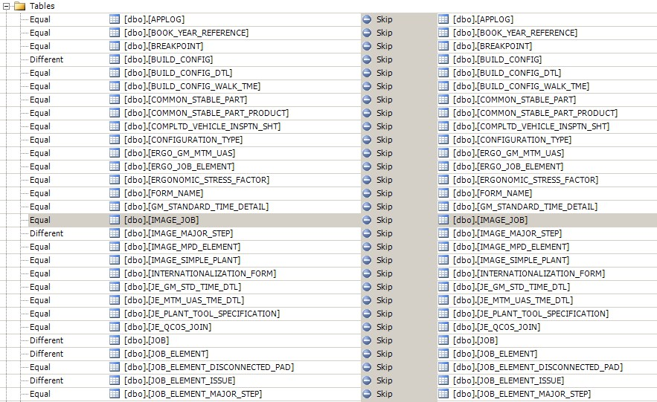

All the objects are just the same.